Plot (Exercise 1):

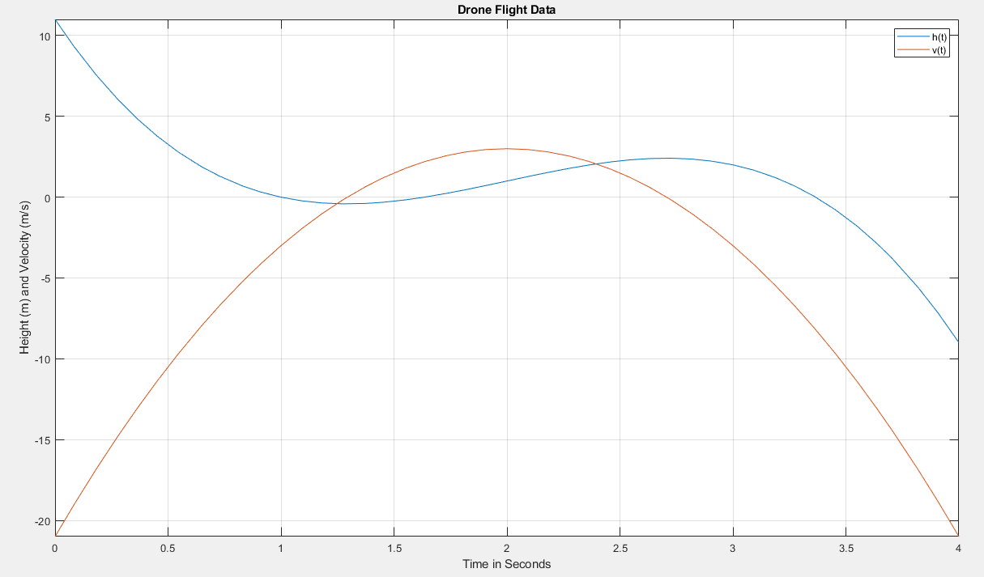

Code with Comments:

%This is the code for Exercise 1

%Create symbolic variable

syms t

%Defining the h(x) function

f=-2.\*(t-2).^3+3.\*(t-2)+1

%Plotting the h(x) function

fplot (f,[0 4])

%Display the grid on the graph

grid on

%Retains plots in the current axes

hold on

%Finding the derivative of h(x), which in this case is the velocity

y=diff(f)

%Plotting the v(x) function

fplot (y, [0 4])

%Labelling the Title

title ('Drone Flight Data')

%Labelling the legend

legend ('h(t)','v(t)')

%Labelling the x-axis

xlabel ('Time in Seconds')

%Labelling the y-axis

ylabel ('Height (m) and Velocity (m/s)')